Game Design Document

Fill up the following document

1. Write the title of your project.

Answer: Mary’s journey

1. What is the goal of the game?

Answer: reducing the weight of Mary

1. Write a brief story of your game.

Answer: there is a girl named Mary who had a surgery recently and as side effect, she gained a lot of weight. Everyone used to teese her and doctors also suggected her that this is not good for her health, so she decided that she will anyhow reduce her weight

. Which are the playing characters of this game?

* Playing characters are the ones who respond to the user based on the input from the user.
* Cars, monkeys, dinos, wizards, etc., are the playing characters in the game.

|  |  |  |
| --- | --- | --- |
| Number | Character Name | What can this character do? |
| 1 | Mary | The one who wants to reduce her weight |

Which are the Non-Playing Characters of this game?

* Non-Playing characters are the ones that don't have an action or behavior when the user interacts with the game.
* Hurdles, stones, bananas, coins, etc., are non-playing characters in the game.

|  |  |  |
| --- | --- | --- |
| Number | Character Name | What can this character do? |
| 1 | apple | A healthy option for Mary which will help her to reduce her weight |
| 2 | burger | An unhealthy option for Mary which will increase her weight |
| 3 | juice | A healthy option for Mary which will help her to reduce her weight |
| 4 | lemonade | An option for Mary which will neither increase nor decrease her weight |
| 5 | salad | A healthy option for Mary which will help her to reduce her weight |
| 6 | pizza | An unhealthy option for Mary which will increase her weight |
| 7 | samosa | An unhealthy option for Mary which will increase her weight |

Draw your imagination of this game. What does this game look like?

* Draw the game either on your computer or on paper.
* Add images of the game scenes to show each of the playing and non-playing characters at least once.

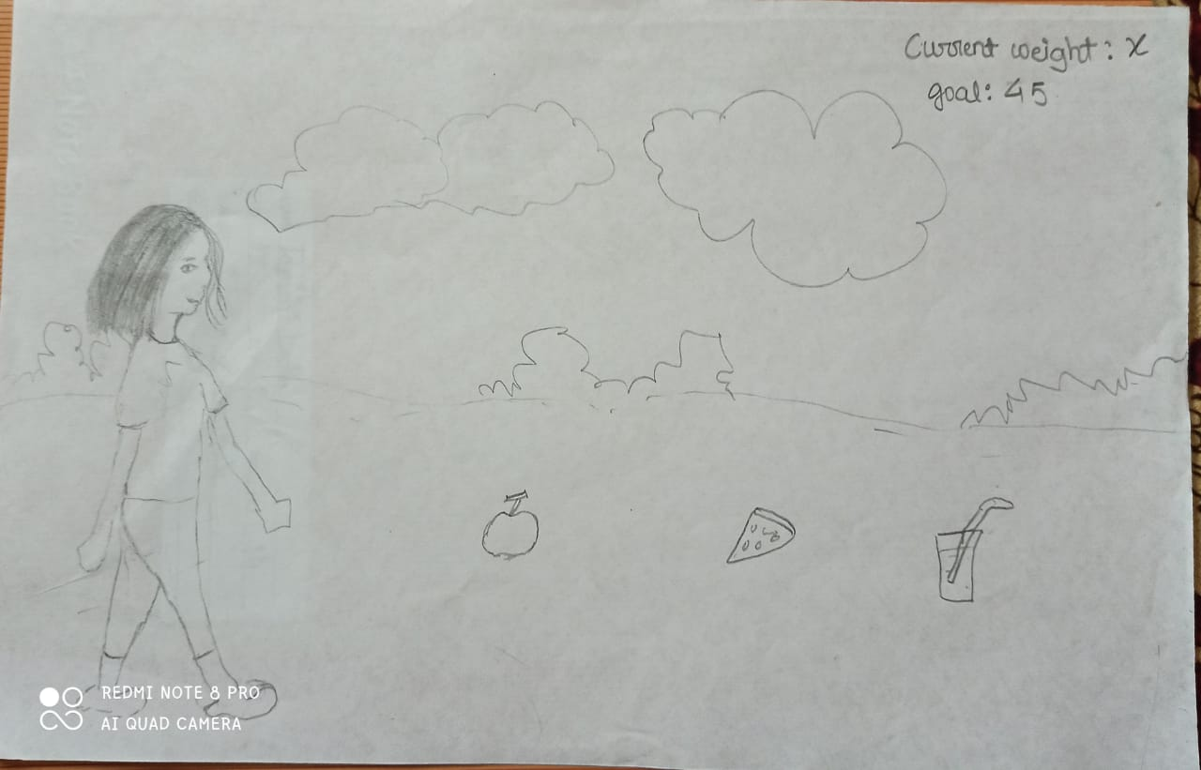

*Mary’s picture(pc)* *rough sketch of the game*

How do you plan to make your game engaging?

Answer: I plan to make the engaging by adding some challenge for the player. For eg: a weight meter, which gives the information about Mary’s current weight, player need to pick the healthy options spawned in the path to manage.